# Required Components

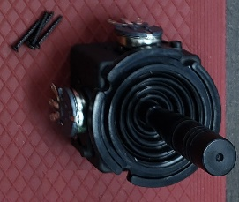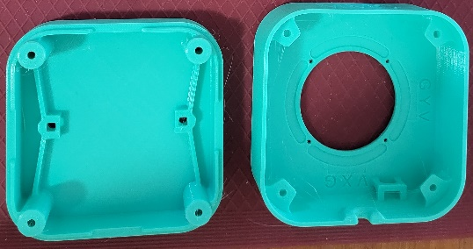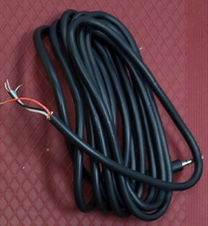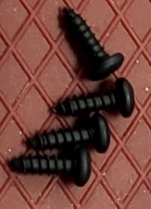

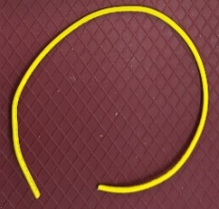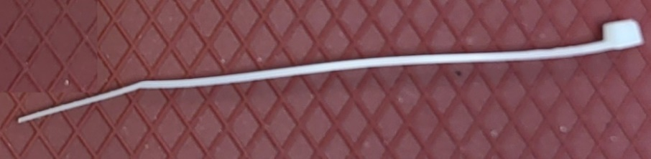

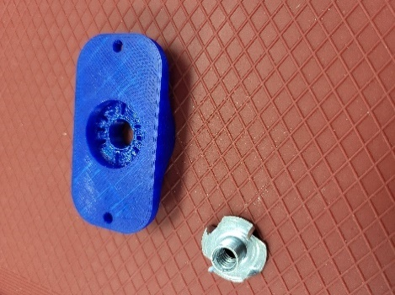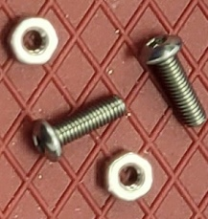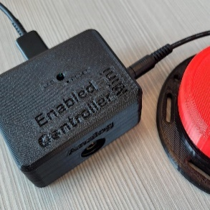

|  |  |
| --- | --- |
| 1. Adafruit mini analog joystick 2. 3D printed enclosure top 3. 3D printed enclosure bottom 4. TRRS Cable 5. #4 3/8” screws x4 6. Extra 24 AWG wire | 1. Ziptie 2. Optional materials (not pictured) 3. 3D printed camera mount adapter 4. Tee nut 5. M3 screws x2 6. M3 nuts x2 7. Assembled Enabled Controller Mini |

# Required Tools

* Philips screwdriver
* Soldering iron and solder
* Electrical continuity tester
  + Multimeter
* ¼-20 Hex Bolt (Optional)

# Required Personal Protective Equipment (PPE)

* Safety goggles

# Assembly Instructions

For the next steps, the following diagram and table show the wiring. You should use a multimeter or other continuity tester to confirm which wire corresponds to which part of the plug. Follow this [guide for checking continuity](https://www.youtube.com/watch?v=T4p8UQZqh5U) to determine which wire corresponds to the sleeve, ring 1, ring 2, and tip of the TRRS cable.

**Note:** If you bought a TRRS cable with plugs on both ends instead of the preprepared one, then take the 3.5 mm TRRS cable, cut to the desired length (typically 1 m). Strip off approximately 3 cm of the outer insulation. Then separate the individual inner wires and strip off approximately 0.5 cm of insulation.

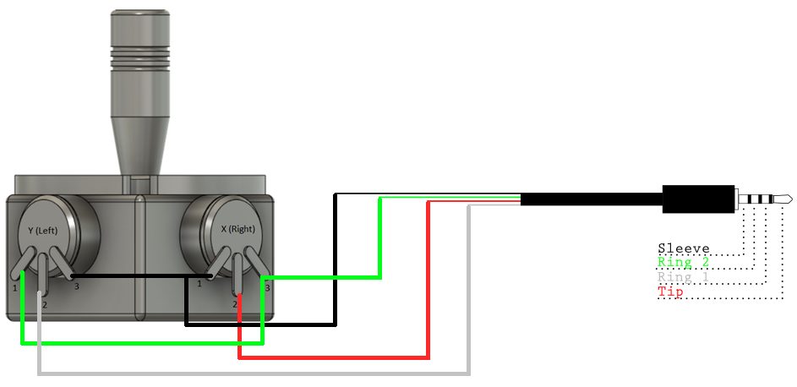

|  |  |
| --- | --- |
| Potentiometer Label | TRRS Cable |
| V (y3-x1) | Sleeve (Black) |
| G (Y1-X3) | Ring 2 (Green) |
| Y (y2) | Ring 1 (White) |
| X (x2) | Tip (Red) |

## Step 0: Remove The Ring

The Adafruit Mini Analog Joystick comes with a ring that screws into the top. You **will not need** this ring and can dispose of it.

## Step 1: Prepare Wires

Cut two pieces of wire, one 8 cm long, the other 5 cm long. Strip 1 cm off the ends of both wires.

## Step 2: Wire Ground and Voltage on the Joystick

With the joystick oriented so the corner between the two potentiometers is facing you, connect the inner two potentiometer pins using the 5 cm wire and the outer two potentiometer pins using the 8 cm wire. **Do not** solder these connections yet.

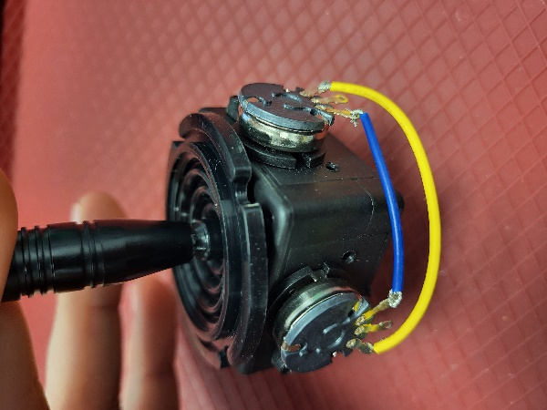

**NOTE**: You can also refer to the engraving in the top enclosure piece for wiring the joystick. (Step 3) Also be sure to keep the joystick oriented with the corner between the two potentiometers facing you.

## Step 3: Wire the TRRS Cable to the Joystick

1. Connect the inner wire of the TRRS cable that connects to the Sleeve (black) to one of the inner potentiometer pins (V) that you just connected with the 5cm wire. Solder the inner potentiometer pins.
2. Connect the inner wire of the TRRS cable that connects to Ring 2 (green) to one of the outer potentiometer pins (G) that you just connected with the 8cm wire. Solder the outer potentiometer pins.
3. Solder the inner wire of the TRRS cable that connects to Ring 1 (white) to the left potentiometer pin (Y). Solder the inner wire of the TRRS cable that connects to the Tip (red) to the right potentiometer pin (X).

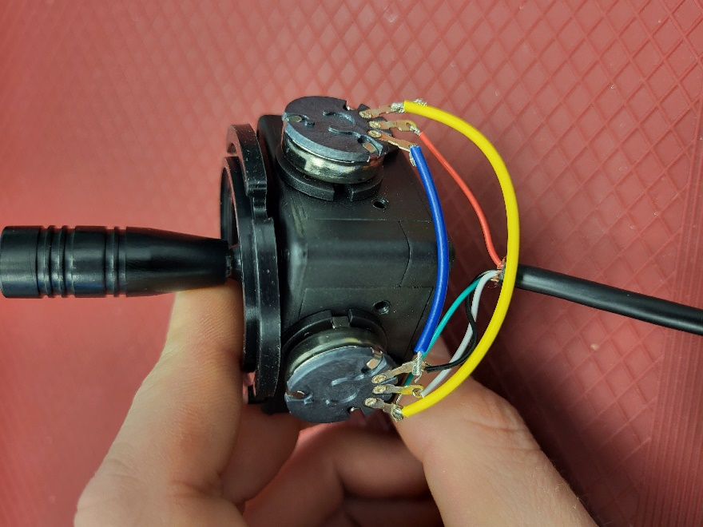

**Note**: Check to ensure there are no bridged connections.

## Step 4: Install Joystick into Enclosure

Screw the joystick into the top piece of the enclosure. Ensure the two rectangular engravings on the lid match with the potentiometers on the joystick.

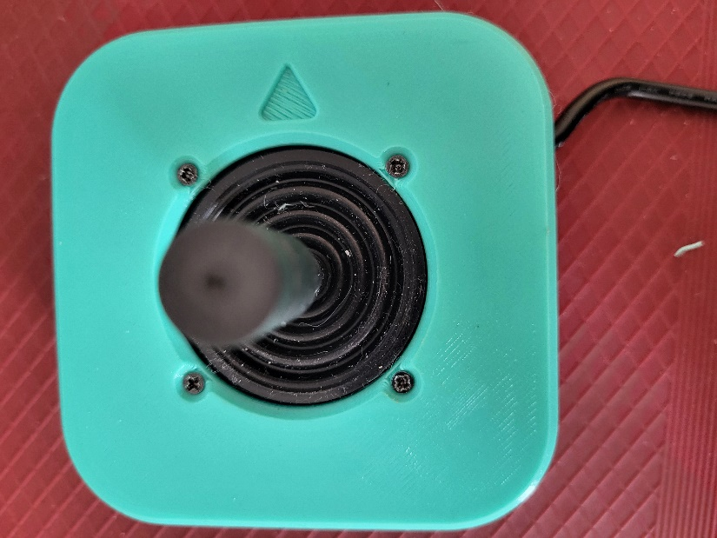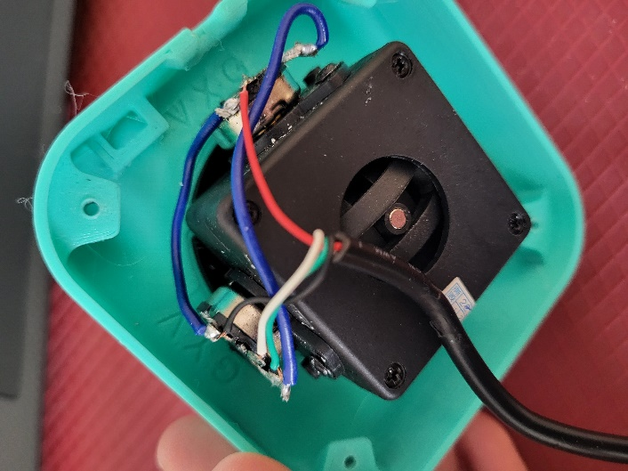

## Step 5: Secure TRRS Cable in Place

Use a cable tie to secure the TRRS cable to the cable routing mount on the interior of the top enclosure piece. Cut the excess end of the cabl tie off.

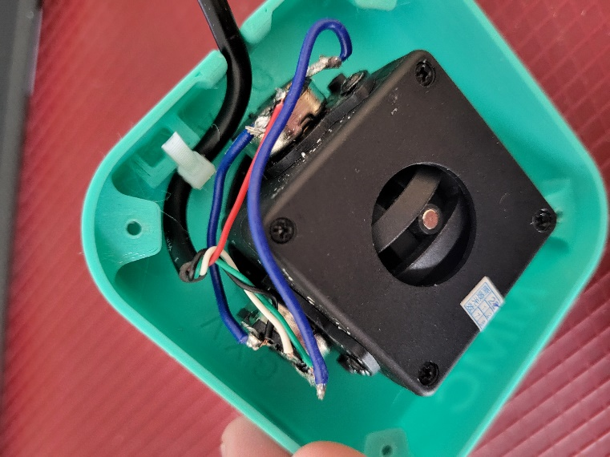

## Step 6: Add Nuts for Mounting Adapter

Slide the M3 nuts into the slots in the bottom enclosure piece.

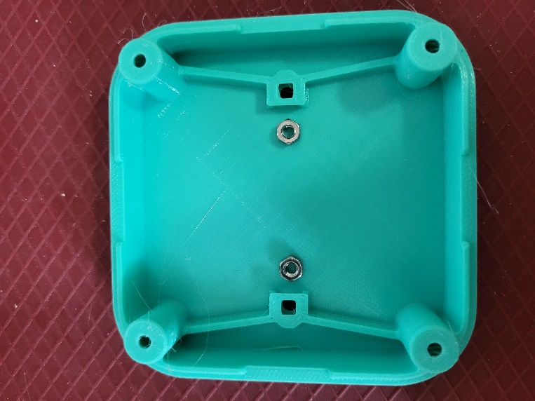

## Step 7: Assemble and Secure Enclosure

Using the #4 3/8” screws, screw the bottom enclosure to the top enclosure. You then have your completed joystick.

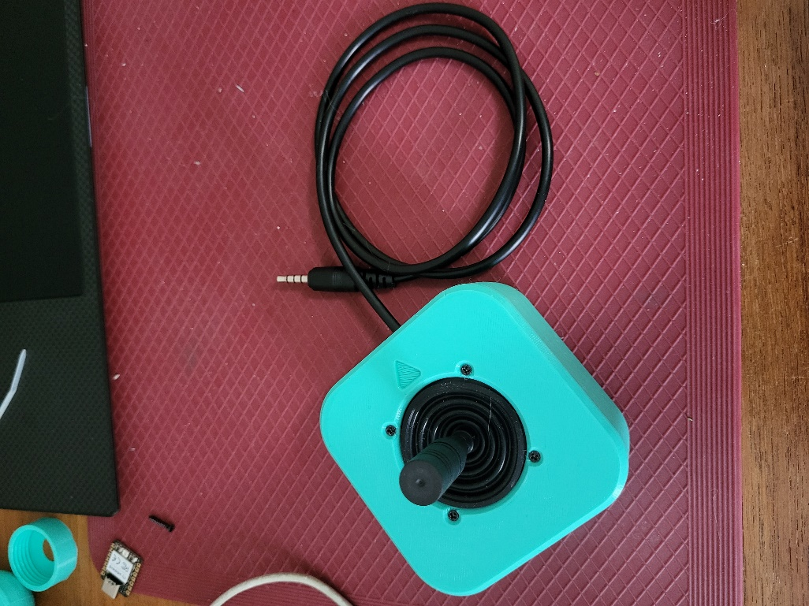



WARNING: If pins are shorted, they may damage the USB port on your computer.

Before plugging in your Enabled Controller Mini and Oak – A joystick into your computer, check over the connections to ensure there is no unintended bridging/connections between pins. You can use a multimeter to test the connections if you’d like and ensure continuity only where it should occur.

## Programming Custom Code to Enabled Controller Mini

1. Setup Arduino IDE
   1. Download Arduino IDE for your operating system at <https://www.arduino.cc/en/software>
   2. Install Arduino IDE
2. Setup Core
   1. Open Arduino IDE
   2. Click on **File -> Preferences**
   3. Locate the text field that says **Additional Boards Manager URLs** beside it.
   4. Copy and paste the following link into the field as a new line:  
      [**https://adafruit.github.io/arduino-board-index/package_adafruit_index.json**](https://adafruit.github.io/arduino-board-index/package_adafruit_index.json)
   5. Click on **OK**
   6. Restart the Arduino IDE
   7. Open the **Boards Manager** option from the **Tools-> Board-> Boards Manager..., search for “Adafruit SAMD” and select “Adafruit SAMD Boards” by Adafruit**
3. **Install Libraries**
   1. Go to <https://github.com/cyborg5/TinyUSB_Mouse_and_Keyboard> and go to Code -> Download ZIP
   2. Click on **Sketch -> Include Library -> Add .ZIP Library**
      1. Select “TinyUSB_Mouse_and_Keyboard” from your downloads to add into your Arduino/libraries folder
   3. Go to **Tools -> Manage Libraries…,** search for “Flash Storage” and install the library “FlashStorage” by Arduino
4. Upload the Code to the joystick
   1. Open OpenAT_Joystick_Mouse_M0_Software_Enabled_Controller_Mini.ino with Open Arduino IDE.
   2. Edit the value of **Line 36: Mouse_Mode_Enabled**, to select either Mouse or Gamepad Mode. True for Mouse Mode, False for Gamepad Mode.
   3. **Select Adafruit QT Py M0 (SAMD21) from Tools -> Board -> Adafruit SAMD Boards**
   4. Click on **Tools -> USB Stack** and select **Adafruit TinyUSB**
   5. Connect the joystick using the USB cable to the computer.
   6. Select the correct port from **Tools -> Port** menu.
   7. Verify and upload the code.

# Testing

## Testing using the Enabled Controller Mini

1. Make sure the code has been flashed in Gamepad Mode (Mouse_Mode_Enabled false)
2. Connect the joystick using the USB C cable to the computer.
3. If using Windows, open “Set up USB Game Controllers” from the Control Panel. You can find this by searching your computer in the search bar next to the Windows icon.
4. Ensure that the joystick is registered as a game controller and select your joystick from the list and go to “Properties”.
5. Move your joystick and observe the movement of the cross hatch in the “Axes” window. Ensure it moves in the proper directions when you move the joystick (the arrow points in the up direction). If not, open the joystick and check your connections.
6. Using assistive switches plugged into each mono jack, activate each switch, and ensure that one of buttons 1-4 light up when you press the switch, and stops when you release the switch. If not, open the joystick and check your connections.

## Testing using an Xbox Adaptive Controller

1. Connect the Xbox Adaptive Controller (XAC) using a USB C cable to the computer.
2. Plug the joystick into either X1 for the left joystick or X2 for the right joystick.
3. If using Windows, open “Set up USB Game Controllers” from the Control Panel. You can find this by searching your computer in the search bar next to the Windows icon.
4. Select the Xbox Adaptive Controller from the list of controllers and go to “Properties”.
5. Move your joystick and observe the movement of the cross hatch in the “Axes” window. Ensure it moves in the proper directions when you move the joystick (the arrow points in the up direction). If not, open up the joystick and check your connections.

Alternatively, you could use the XAC with Steam or an Xbox itself to test that moving the joystick results in the corresponding movements on the controller.

# Optional – Camera Mount

To mount the joystick on a camera mount, the optional Joystick Camera Mount Adapter can be used.

|  |  |
| --- | --- |
| Step 1 Flip the camera mount adapter around to reveal the recess with small slots.  Ensure all supports are removed from the 3D print. | Blue 3D printed part for the camera mount adapter. There are two holes on the sides and one hole in the middle with small slots around it. |

|  |  |
| --- | --- |
| Step 2 Insert the tee nut, lining up the barbs with the small slots in the 3D print. | Blue 3D printed part for the camera mount adapter, with a tee nut sitting inside of it, not fully inserted. |

|  |  |
| --- | --- |
| Step 3 Flip the part around and screw in a ¼-20 hex bolt. | Blue 3D printed part for the camera mount adapter, with a hex bolt being screwed into it. There is a white arrow showing to screw in the hex bolt clockwise. |

|  |  |
| --- | --- |
| Step 4 Tighten the bolt until the tee nut is seated down as far as possible. | Top of the camera mount adapter, with a hex bolt fully screwed into it. There is a white arrow showing to screw in the hex bolt clockwise. Bottom of the camera mount adapter, showing a tee nut fully installed into the 3D print, and sitting flush. There are two arrows pointing down to indicate that the tee nut is all the way down. |

|  |  |
| --- | --- |
| Step 5 Using 2 M3 screws, screw the camera mount adapter to the bottom of the joystick in the two middle holes. | The camera mount adapter screwed into the bottom of the joystick, using two small screws. Both the camera mount adapter and the joystick are light blue. The screws are circled in red. |